OOP Lab Practical – 7

Name: Divyam Kumar

SAPID: 500083141

Roll No: R214220434

Batch: B2

**Title: Packages**

1. Write a Java program to implement the concept of importing classes from user defined package.
2. Write a program to make a package Balance. This has an Account class with Display_Balance method. Import Balance package in another program to access Display_Balance method of Account class.
3. Write a java program that creates a package calculation. Add following classes in it:
4. Addition
5. Subtraction
6. Division
7. Multiplication

Write another Test class, import and use the above package.

Question 1:

ALGORITHM:

Step 1: START

Step 2:Create package mp

Step 3: Inside in package mp create class Display

Step 4:import claas Display from package mp

Step 5: END

CODE:

package mp;

public class Display

{

public static void main(String[] args)

{

System.out.println("Hello World");

}

}

OUTPUT:

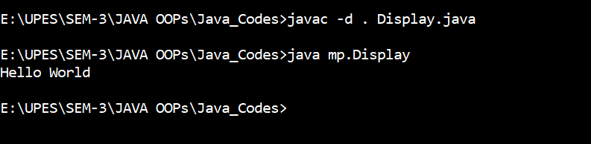

Question 2:

ALGORITHM:

Step 1: START

Step 2:Create package Balance

Step 3:Inside package Balance create class Account

Step 4:Define method Display_Balance inside class Account

Step 5:Create another class Bank

Step 6: Import package Balance in Bank

Step 7: Define main function inside class Bank

Step 8: Create object a of class Account

Step 9: Call the method Display_Balance

Step 10:END

CODE:

//package

package Balance;

public class Account

{

public void Display_Balance() {

System.out.println("Your Balance: 10000Rs");

System.out.println("Divyam Kumar \n 500083141");

}

}

//class Bank

import Balance.Account;

public class Bank

{

public static void main(String[] args)

{

Account a = new Account();

a.Display_Balance();

}

}

OUTPUT:

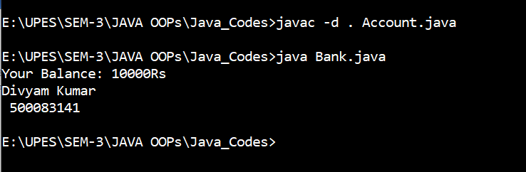

Question 3:

ALGORITHM:

Step 1: START

Step 2:Create package Calculation

Step 3:Inside package Calculation create class Calculator

Step 4:Define methods add(double a, double b), diff (double a, double b), mul (double a, double b), div(double a, double b) to perform different mathematical calculations

Step 5:Create another class Testing

Step 6: Define main function in class a Testing

Step 7: Initialize 2 variable a and b as double

Step 8: Take input of 2 values for a and b

Step 9: Create object c for the class Calculator

Step 10:Call the methods add(a, b) , diff(a, b) , mul(a, b) , div(a, b)

Step 11:END

CODE:

//package

package Calculation;

public class Calculator

{

public void add(double a , double b)

{

System.out.println("Sum: "+(a+b));

}

public void diff(double a , double b)

{

System.out.println("Difference: "+(a-b));

}

public void mul(double a , double b)

{

System.out.println("Product: "+(a*b));

}

public void div(double a , double b)

{

System.out.println("Division: "+(a/b));

}

}

//class Testing

import java.util.*;

import Calculation.Calculator;

class Test

{

public static void main(String[] args) {

Scanner sc = new Scanner(System.in);

double a,b;

System.out.println("Enter 2 numbers:");

a = sc.nextDouble();

b = sc.nextDouble();

Calculator c =new Calculator();

c.add(a,b);

c.diff(a,b);

c.mul(a,b);

c.div(a,b);

System.out.println("Divyam Kumar \n 500083141");

}

}

OUTPUT:

